**Initial ERD**

Control Centres

Control Desks

Drivers

Cars

Journeys

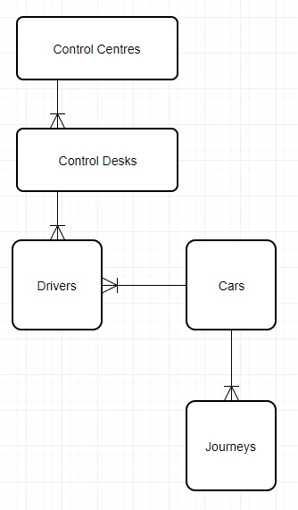

Assumptions:

-Journeys are made by cars, not drivers. I.e. journeys in the database will be saved under cars not drivers

**Initial Normalisation**

**UNF**

Control centre ID

Control desk ID

Vehicle reg

Car make

Passenger limit

(Driver ID

Driver first name

Driver last name

Days of work

Shift)

(Call ID

Customer ID

Date-time

Pick up address

Pick up postcode

Dest address

Dest postcode

Note

Credit card

Driver ID)

**1NF**

Vehicle reg

Centre ID

Desk ID

Car make

Passenger limit

Vehicle reg

Driver ID

Driver first name

Driver last name

Days of work

Shift

Vehicle reg

Call ID

Customer ID

Date-time

Pick up address

Pick up postcode

Dest address

Dest postcode

Note

Credit card

Driver ID

**2NF**

Vehicle reg

Centre ID

Desk ID

Car make

Passenger limit

Vehicle reg

Driver ID

Days of work

Shift

Driver ID

Driver first name

Driver last name

Vehicle reg

Call ID

Date-time

Pick up address

Pick up postcode

Dest address

Dest postcode

Driver ID

Call ID

Note

Credit card

Customer ID

**3NF**

[Cars]

Vehicle reg

Centre ID*

Passenger limit*

[Control]

Centre ID

Desk ID

[Car Types]

Passenger limit

Car make

[Rota]

Vehicle reg

Driver ID

Days of work

Shift

[Drivers]

Driver ID

Driver first name

Driver last name

[Journeys]

Vehicle reg

Call ID

Date-time

Pick up postcode*

Dest postcode*

Driver ID*

[Pick ups]

Pick up postcode

Pick up address

[Drop Offs]

Dest postcode

Dest address

[Customers]

Call ID

Note

Credit card

Customer ID

**ERD Using Normalisation Forms**

